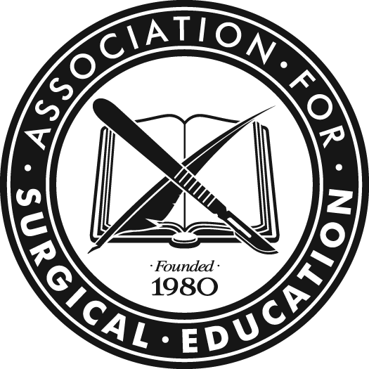
EXCELLENCE IN SURGICAL EDUCATION AWARDS

EXCELLENCE IN INNOVATION

IN SURGICAL EDUCATION AWARD

The Excellence in Innovation in Surgical Education Award is an award established by the Association for Surgical Education to recognize exemplary performance by surgical educators. This award is designed to advance the mission of the Association for Surgical Education to promote excellence, innovation and scholarship in surgical education and will be awarded annually. The intent is to recognize specific innovations (novel ideas and/or methods for improving teaching and learning) and reward collaboration in surgical education. Award applications will be judged based on the quality and uniqueness of the innovation, the process used in creating and implementing the innovation, the demonstrated results, and the impact and potential impact on the broader community and future of surgical education. The award criteria are intentionally general so as to allow applicants to submit a broad variety of collaborations which may include innovative projects or programs at the undergraduate, graduate or continuing education level.

Eligibility

■ At least one member of the innovation team must be a member of Association for Surgical Education

Nomination Process

■ Nominations will be solicited by the ASE President on an annual basis
■ Nominations will be made by a member of the Association for Surgical Education and signed by their Department Chair
■ Members/ Department chairs are limited to submitting a single nomination per year
■ Innovations should have taken place within the last five years. Alternatively, if an innovation was implemented prior to the past five years, then it should have demonstrated ongoing impact on the current field of surgical education.
- A summary statement describing the innovation, the problem it addressed and a description of the collaborative process is required.
- If the summary statement is not included, the nomination will not be accepted.

June Request for nominations sent by ASE President
September 15 Deadline for receipt of nominations
September 15 – Jan. 15 Deliberations of the Awards Committee
January 15 Winners selected and notified. ASE Executive Director and ASE President notified
by Committee Chair
April Annual meeting
Winners announced – awards given

Awards Committee
Nabil Issa, MD, Chair
Robert Acton, MD
Roy Phitayakorn, MD
Amalia Cochran, MD
Kyla Terhune, MD

ASE AWARD FOR INNOVATION IN SURGICAL EDUCATION

(To be filled out by nominating member and signed by Department Chair)

NAME of NOMINATING MEMBER:

_____________________________________________________________________________________________
NAMES OF INNOVATION AND INNOVATION TEAM:

_____________________________________________________________________________________________
_______________________________________________________________________________________________________________________________________________________________________________________________________________________________________________________________________________________

INSTITUTION(s)
NOMINATING MEMBER:______________________________________________________________________

INNOVATION TEAM: _______________________________________________________________________________________________________________________________________________________________________________________________________________________________________________________________________________________

MAILING ADDRESS:

NOMINATING MEMBER: ________________________________________________________________________________________________________________________________________________________________________________________________________________________________________________________________________________________________________________________________________________________
EMAIL:___________________________________________PHONE:_____________________________

Applicants should provide the following information (Please limit your entry to 2000 words maximum):

- The innovation team
  - At least one member of the innovation team should be a member of the ASE.
  - Please provide a corresponding applicant
  - Provide a list of involved collaborators and their role in the innovation
- A description of the problem addressed by the innovation:
  - What problem does the innovation address?
  - What audience was impacted by the innovation?
  - Describe the desired goals of the innovation.
- A description of the collaborative process used in designing and implementing the innovation
  - What process was used to design the innovation?
  - Please describe the innovation
  - How was the innovation implemented?
- The results of the innovation
  - Please describe outcomes measured and results.
  - What impact has the innovation had?
  - Is the innovation reproducible /sustainable/ generalizable to a broader audience?
- How have the results of the innovation been disseminated?
  - Please list presentations, publications of this work
  - Has this innovation been implemented elsewhere?
- How has this innovation impacted surgical education?
  - What have you learned in the process that will affect future application of this innovation?

_________________________________________ __________________________________________
Signature of Nominating Member Signature of Department Chair

Please scan all materials into one PDF file and send electronically to Susan Kepner at skepner@surgicaleducation.com. No hard copies will be accepted.

